Unit-3

Entity Relationship Model
An Entity–relationship model (ER model) describes the structure of a database with the help of a diagram, which is known as Entity Relationship Diagram (ER Diagram). An ER model is a design or blueprint of a database that can later be implemented as a database. The main components of E-R model are: entity set and relationship set.

What is an Entity Relationship Diagram (ER Diagram)?
An ER diagram shows the relationship among entity sets. An entity set is a group of similar entities and these entities can have attributes. In terms of DBMS, an entity is a table or attribute of a table in database, so by showing relationship among tables and their attributes, ER diagram shows the complete logical structure of a database.

A simple ER Diagram:
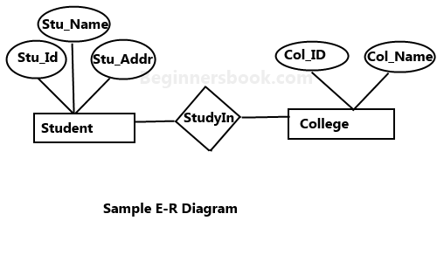
In the following diagram we have two entities Student and College and their relationship. The relationship between Student and College is many to one as a college can have many students however a student cannot study in multiple colleges at the same time. Student entity has attributes such as Stu_Id, Stu_Name & Stu_Addr and College entity has attributes such as Col_ID & Col_Name.
Here are the geometric shapes and their meaning in an E-R Diagram. We will discuss these terms in detail in the next section(Components of a ER Diagram) of this guide so don’t worry too much about these terms now, just go through them once.
Rectangle: Represents Entity sets.
Ellipses: Attributes
Diamonds: Relationship Set
Lines: They link attributes to Entity Sets and Entity sets to Relationship Set
Double Ellipses: Multivalued Attributes
Dashed Ellipses: Derived Attributes
Double Rectangles: Weak Entity Sets
Double Lines: Total participation of an entity in a relationship set

Components of an ER Diagram
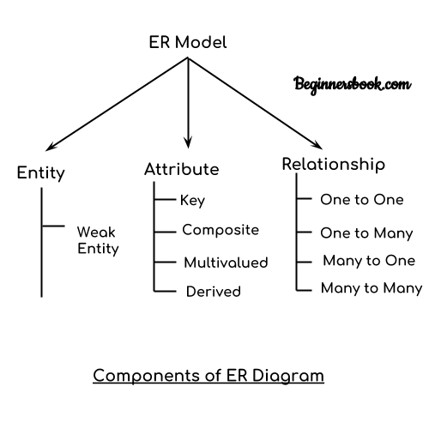
As shown in the above diagram, an ER diagram has three main components:
1. Entity
2. Attribute
3. Relationship

1. Entity
An entity is an object or component of data. An entity is represented as rectangle in an ER diagram.
For example: In the following ER diagram we have two entities Student and College and these two entities have many to one relationship as many students study in a single college. We will read more about relationships later, for now focus on entities.
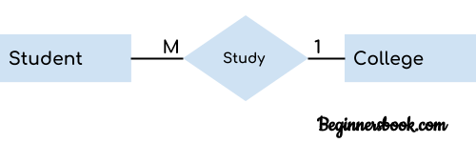
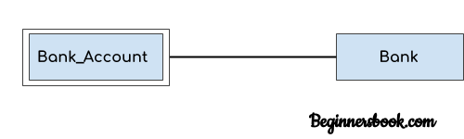
Weak Entity:
An entity that cannot be uniquely identified by its own attributes and relies on the relationship with other entity is called weak entity. The weak entity is represented by a double rectangle. For example – a bank account cannot be uniquely identified without knowing the bank to which the account belongs, so bank account is a weak entity.

2. Attribute
An attribute describes the property of an entity. An attribute is represented as Oval in an ER diagram. There are four types of attributes:
1. Key attribute
2. Composite attribute
3. Multivalued attribute
4. Derived attribute

1. Key attribute:
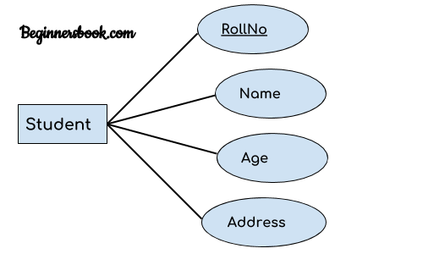
A key attribute can uniquely identify an entity from an entity set. For example, student roll number can uniquely identify a student from a set of students. Key attribute is represented by oval same as other attributes however the text of key attribute is underlined.

2. Composite attribute:
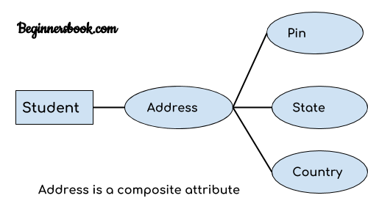
An attribute that is a combination of other attributes is known as composite attribute. For example, In student entity, the student address is a composite attribute as an address is composed of other attributes such as pin code, state, country.

3. Multivalued attribute:
An attribute that can hold multiple values is known as multivalued attribute. It is represented with double ovals in an ER Diagram. For example – A person can have more than one phone numbers so the phone number attribute is multivalued.

4. Derived attribute:
A derived attribute is one whose value is dynamic and derived from another attribute. It is represented by dashed oval in an ER Diagram. For example – Person age is a derived attribute as it changes over time and can be derived from another attribute (Date of birth).
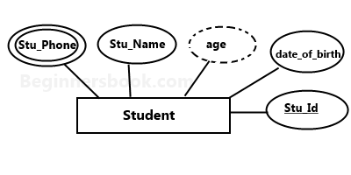
E-R diagram with multivalued and derived attributes:

3. Relationship
A relationship is represented by diamond shape in ER diagram, it shows the relationship among entities. There are four types of relationships:
1. One to One
2. One to Many
3. Many to One
4. Many to Many

1. One to One Relationship
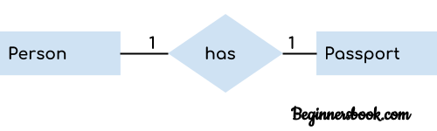
When a single instance of an entity is associated with a single instance of another entity then it is called one to one relationship. For example, a person has only one passport and a passport is given to one person.

2. One to Many Relationship
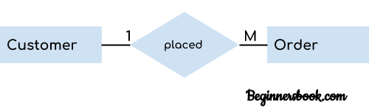
When a single instance of an entity is associated with more than one instances of another entity then it is called one to many relationship. For example – a customer can place many orders but a order cannot be placed by many customers.

3. Many to One Relationship
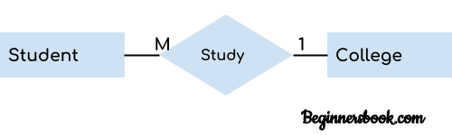
When more than one instances of an entity is associated with a single instance of another entity then it is called many to one relationship. For example – many students can study in a single college but a student cannot study in many colleges at the same time.

4. Many to Many Relationship
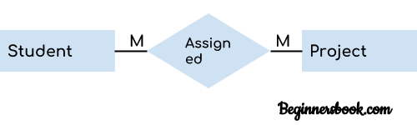
When more than one instances of an entity is associated with more than one instances of another entity then it is called many to many relationship. For example, a can be assigned to many projects and a project can be assigned to many students.
Keys
Primary Key
– A primary is a column or set of columns in a table that uniquely identifies tuples (rows) in that table.
Super Key – A super key is a set of one of more columns (attributes) to uniquely identify rows in a table.
Candidate Key – A super key with no redundant attribute is known as candidate key

Total Participation of an Entity set
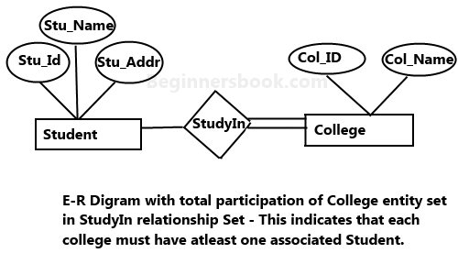
A Total participation of an entity set represents that each entity in entity set must have at least one relationship in a relationship set. For example: In the below diagram each college must have at-least one associated Student.
Use of Extended E-R Features
Generalization
Generalization is a process in which the common attributes of more than one entities form a new entity. This newly formed entity is called generalized entity.

Generalization Example
Lets say we have two entities Student and Teacher.
Attributes of Entity Student are: Name, Address & Grade
Attributes of Entity Teacher are: Name, Address & Salary
The ER diagram before generalization looks like this:
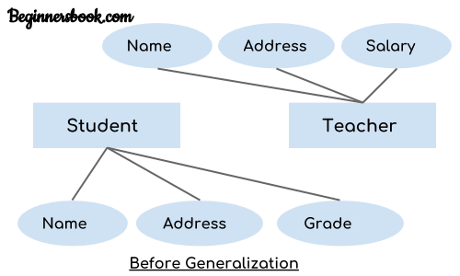
These two entities have two common attributes: Name and Address, we can make a generalized entity with these common attributes. Lets have a look at the ER model after generalization.
The ER diagram after generalization:
We have created a new generalized entity Person and this entity has the common attributes of both the entities. As you can see in the following ER diagram that after the generalization process the entities Student and Teacher only has the specialized attributes Grade and Salary respectively and their common attributes (Name & Address) are now associated with a new entity Person which is in the relationship with both the entities (Student & Teacher).
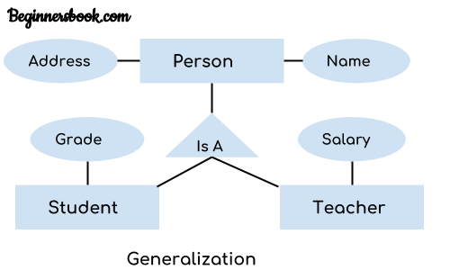

Note:
1. Generalization uses bottom-up approach where two or more lower level entities combine together to form a higher level new entity.
2. The new generalized entity can further combine together with lower level entity to create a further higher level generalized entity.

Specialization
Specialization is a process in which an entity is divided into sub-entities. You can think of it as a reverse process of generalization, in generalization two entities combine together to form a new higher level entity. Specialization is a top-down process.
The idea behind Specialization is to find the subsets of entities that have few distinguish attributes. For example – Consider an entity employee which can be further classified as sub-entities Technician, Engineer & Accountant because these sub entities have some distinguish attributes.

Specialization Example
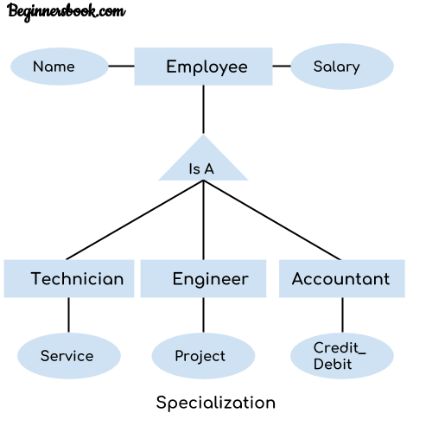
In the above diagram, we can see that we have a higher level entity “Employee” which we have divided in sub entities “Technician”, “Engineer” & “Accountant”. All of these are just an employee of a company, however their role is completely different and they have few different attributes. Just for the example, I have shown that Technician handles service requests, Engineer works on a project and Accountant handles the credit & debit details. All of these three employee types have few attributes common such as name & salary which we had left associated with the parent entity “Employee” as shown in the above diagram.

ER Diagram to Table Conversion
First we will convert simple ER diagrams to tables. In the end, we will take a complex ER diagram and then we will convert it into set of tables.

1. Strong Entity set with Simple attributes
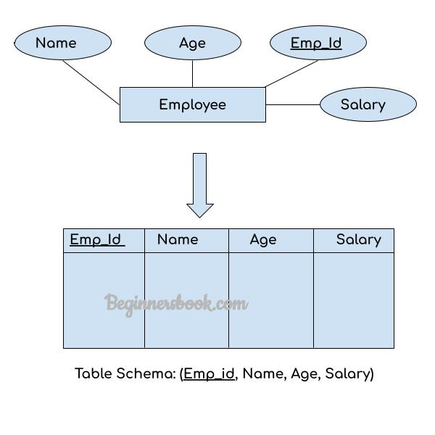

2. Strong Entity Set With Composite Attributes
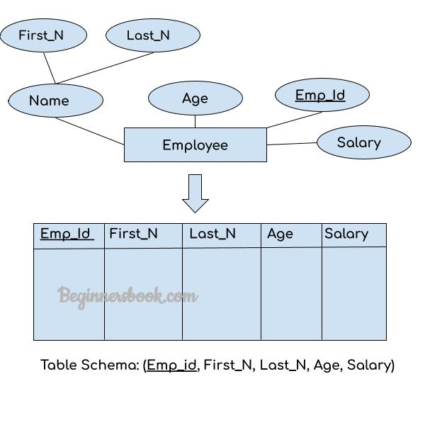

3. Strong Entity Set with Multi Valued Attributes
Entity set with multi-valued attributes will require two tables in the relational model.
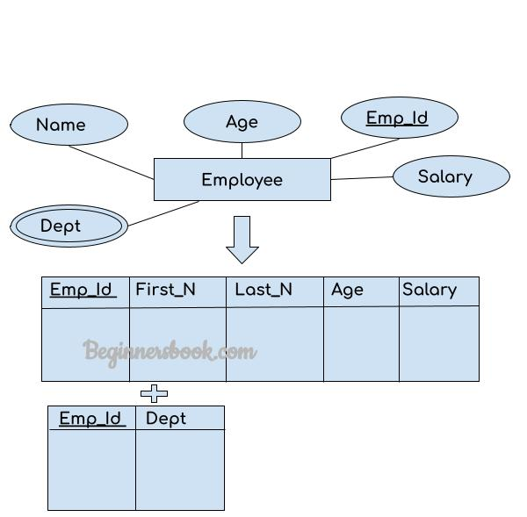

4. Relationship Set to Table conversion
While converting the relationship set to a table, the primary attributes of the two entity sets becomes the table attributes and if the relationship set has any attribute that also becomes the attribute of the table.
